

**UNIVERSITY OF ENGINEERING AND TECHNOLOGY**

***Department of Computer Science***

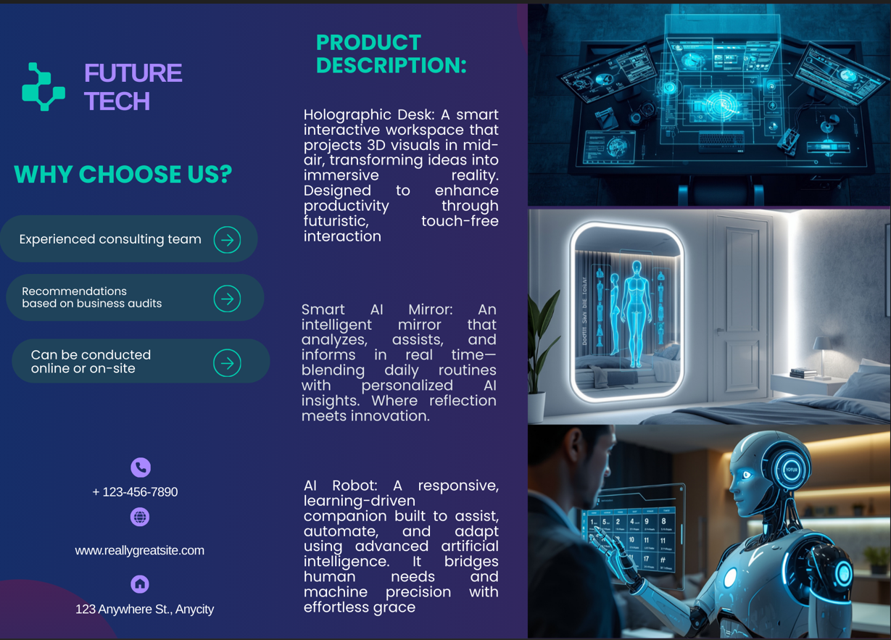

**Project Title:** Tech Product Launch

Submitted By:

Ayesha Fayyaz - Roll No: 2025-GA-21

Qiraat Tahir - Roll No: 2025-GA-50

Meerab Zahid - Roll No: 2025-GA-43

Umair Abu Bakar - Roll No: 2025-GA-04

M.Daud Butt - Roll No: 2025-GA-38

Instructor: Ms. Ramsha Khalid

Course Name: Application of Information and Technology Lab (AICTL)

Section: Gaming and Animation (A)

Submission: 06-01-2025

1. Executive Summary

The **FUTURE TECH** website is more than just a typical product showcase; it is a comprehensive web development project crafted to bridge the gap between today’s coding standards and tomorrow’s technological possibilities. By centering the platform around three flagship AI-driven products the **Holographic Desk**, **Smart AI Robot**, and **Smart Mirror** the project serves as a practical demonstration of how high-end gadgets can be marketed through a seamless digital experience.

The core of this project lies in its balance of aesthetics and functionality. Rather than just listing features, the site uses a modern, sleek interface to guide users through an immersive journey, from initial product discovery to detailed pricing breakdowns and social proof via customer testimonials. Every element from the intuitive navigation to the responsive layout is intentionally designed to showcase professional grade front-end skills. By prioritizing user engagement and a clean, futuristic visual language, the website proves how effective design can turn complex technical concepts into an accessible and exciting product launch for a future ready audience.

1. **Project Objectives & Scope**

**Objectives**

* To present future technology products using a modern UI
* To practice HTML, CSS and basic web structuring concepts
* To create a responsive and user friendly layout

**Scope**

The project includes:

* A homepage introducing FUTURE TECH
* A product section featuring three AI-powered devices
* A testimonials section for customer feedback
* An about and contact section

The project does not include backend functionality or real online purchasing.

**3. Site Structure & Navigation**

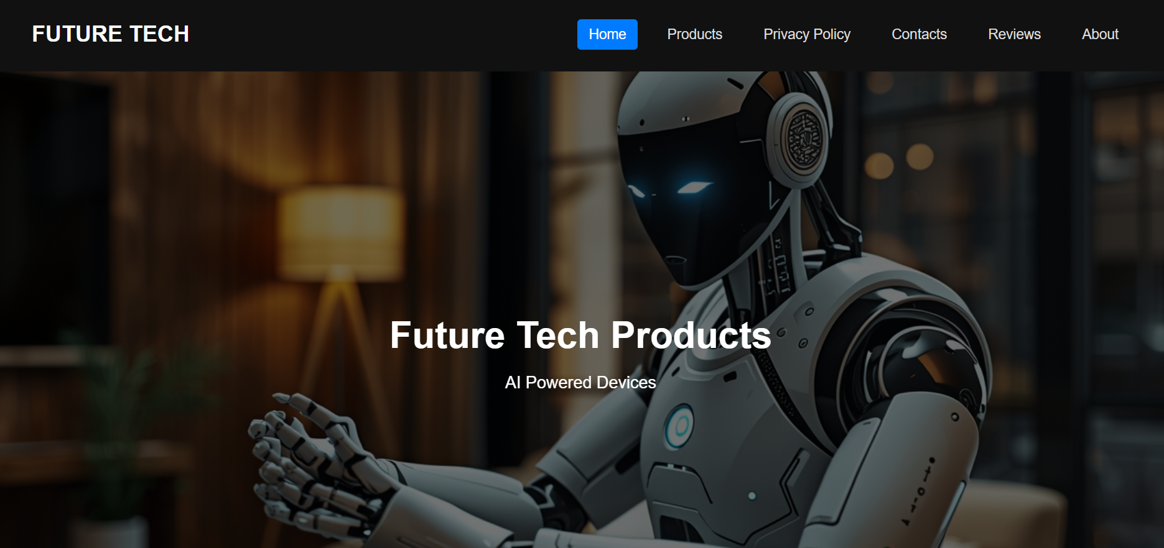

**Website Pages & Purpose**

* **Home:** Introduces the FUTURE TECH brand
* **Products:** Displays featured products with prices
* **About:** Explain the company vision and mission
* **Reviews:** Shows customer testimonials
* **Contact:** Provides communication details
* **Privacy Policy:** Describes user data protection

**Design Choices**

**Fonts**

* Dark background with light text
* Accent colors used to highlight prices and buttons
* Body text is simple and readable

**Colors**

* Dark background with light text
* Accent colors used to highlight prices and buttons
* Consistent color theme across all pages

**Layout Decisions**

* Grid-based product layout
* Balanced spacing and alignment

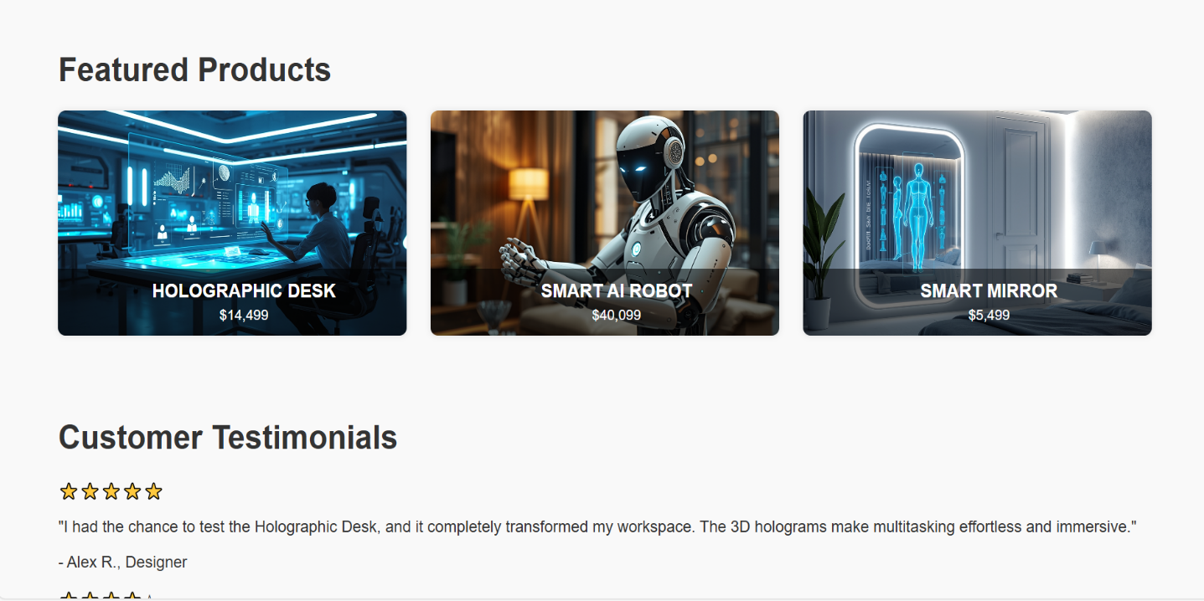

1. **Assets Used**

**Images**

**Products used:**

* Holographic Desk
* Smart AI Robot
* Smart Mirror

**Data Sources**

* Product names, prices, and descriptions are fictional and created for academic purposes only.

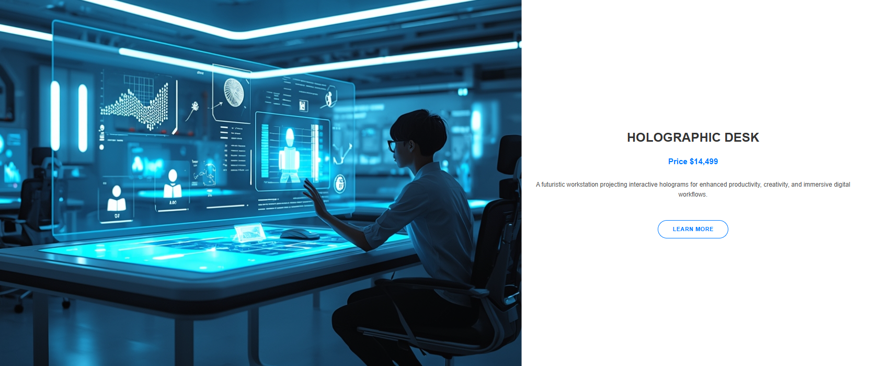

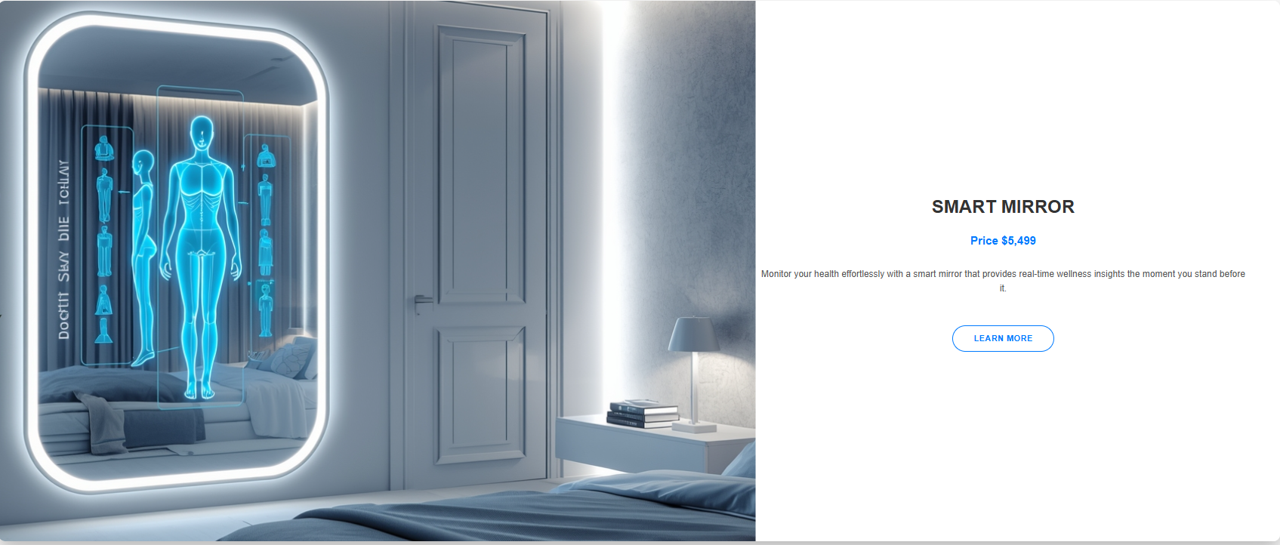

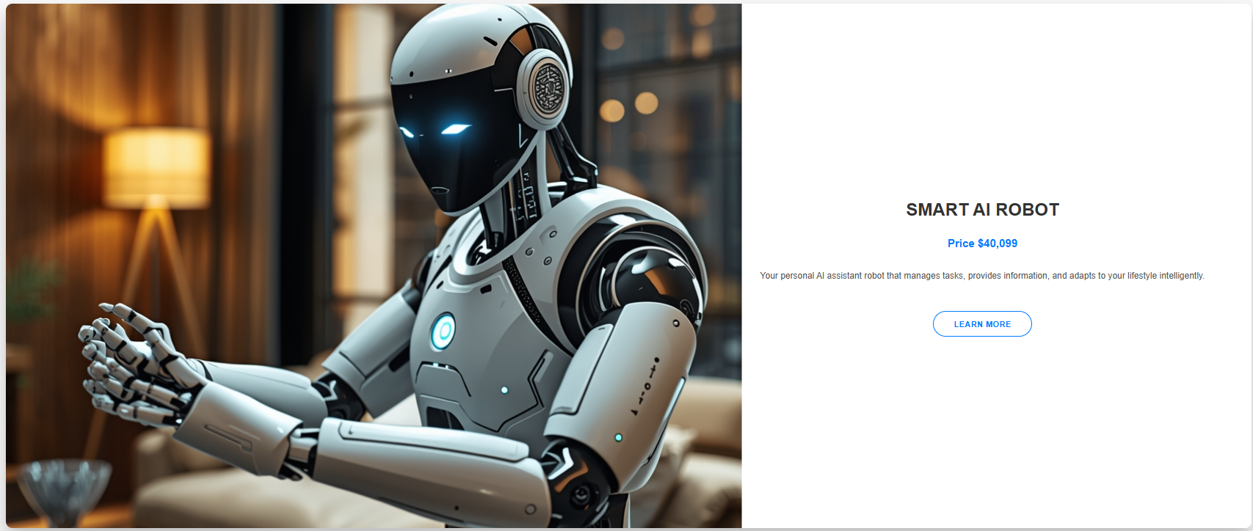

## **How to Run / Publish the Website**

1. Download the project folder
2. Open the folder in any code editor (VS Code recommended)
3. Open index.html in a web browser

**Live Website URL:**

1. **Excel**

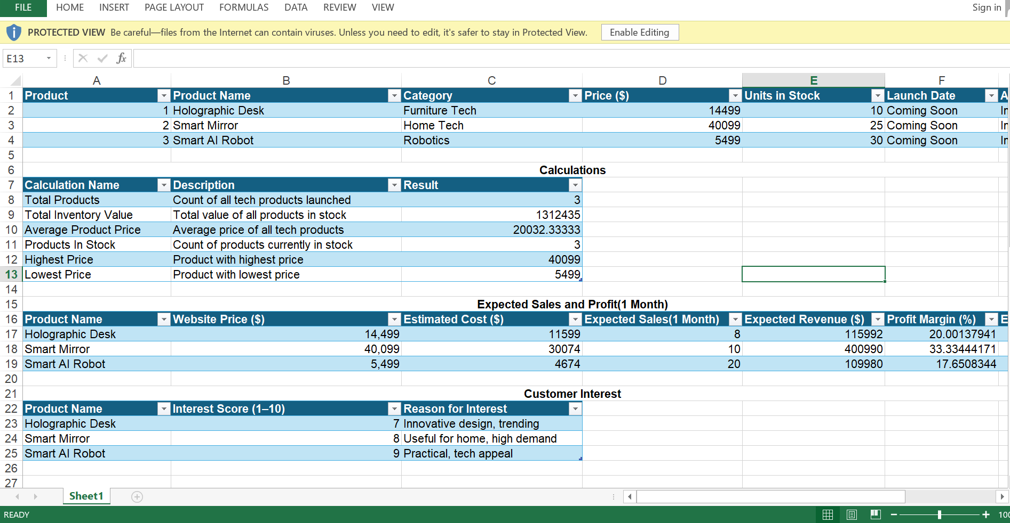

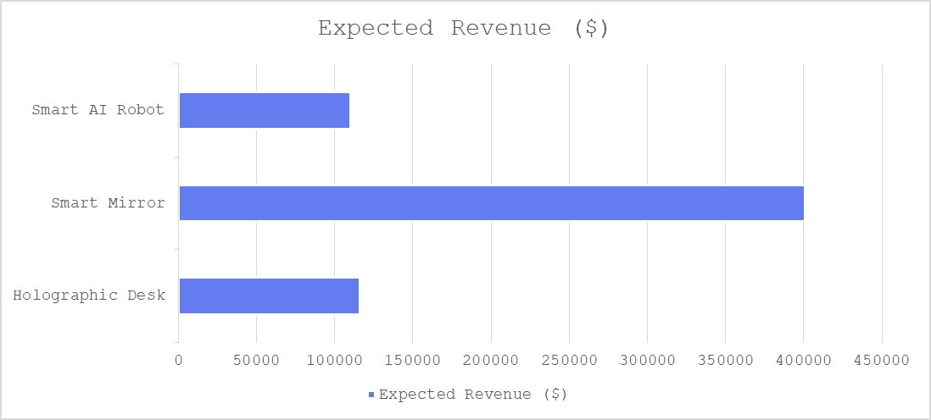

**Figure shows Expected Revenue**

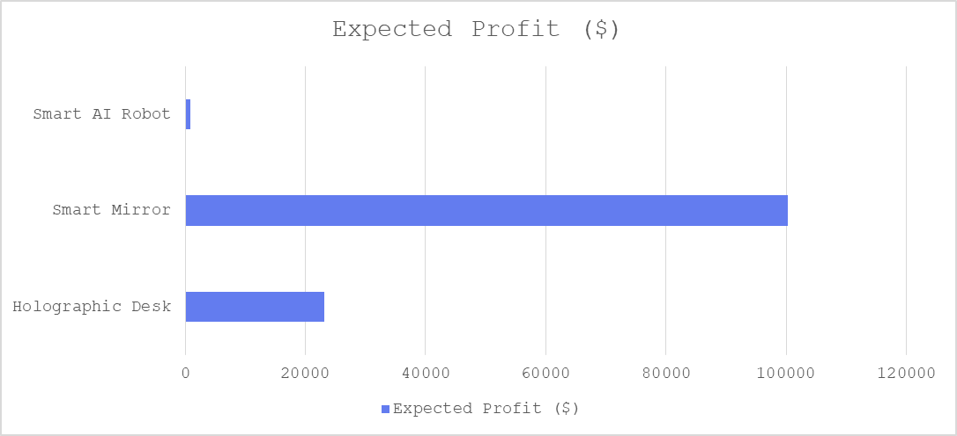

**Figure shows Expected Profit**

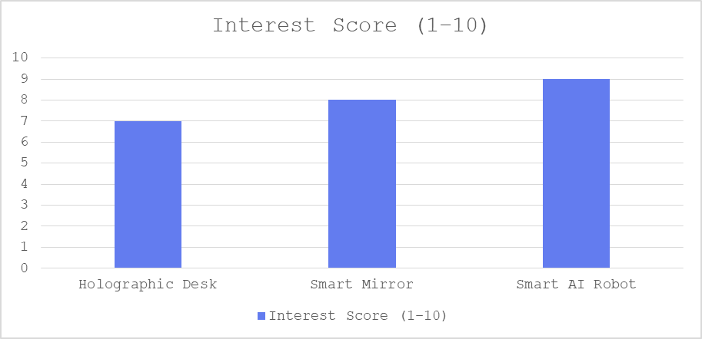

**Figure shows Interest Score**

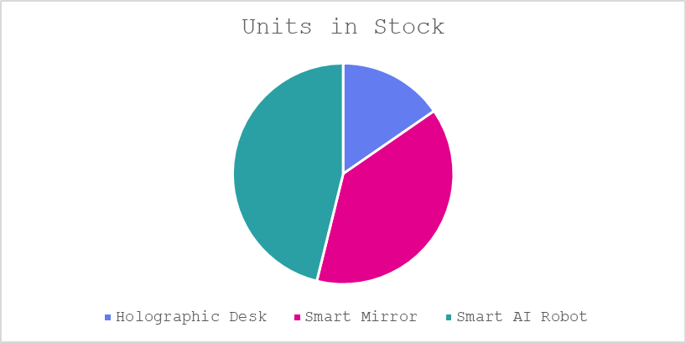

**Figure shows Units in Stock**

1. **Reflections**

Working on the Tech Product Launch website was a highly educational and rewarding experience. This project allowed us to apply our theoretical knowledge of web development in a practical scenario and understand how a website is structured to engage users effectively.

**Learning Outcomes:**

* Gained hands-on experience in creating a responsive and visually appealing website.
* Learned how to structure content logically across multiple pages.
* Practiced using HTML, CSS, and layout designprinciples to create a professional look.
* Understood the importance of user-friendly navigation and consistent design choices.

Areas for Improvement:

* Enhance the website by adding interactive features to increase engagement.
* Improve image optimization for faster loading times.
* Further refine color schemes and font choices to make the design even more professional.
* Include more detailed product descriptions and comparisons for better user understanding.

Overall, this project helped us combine creativity with technical skills and highlighted the importance of planning and design in web development. It strengthened our confidence in designing websites that are both functional and visually appealing.